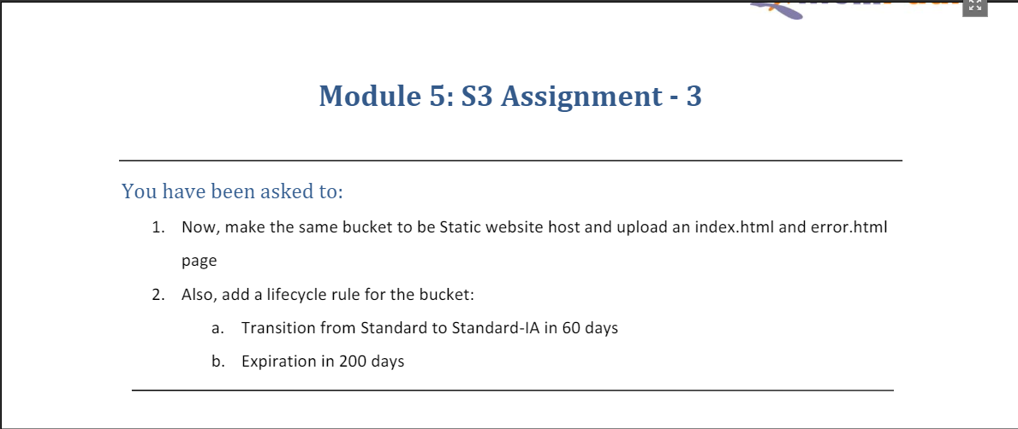

* Uploaded ‘index.html’ and ‘error.html’ on the same bucket (**mod5assignment1**)

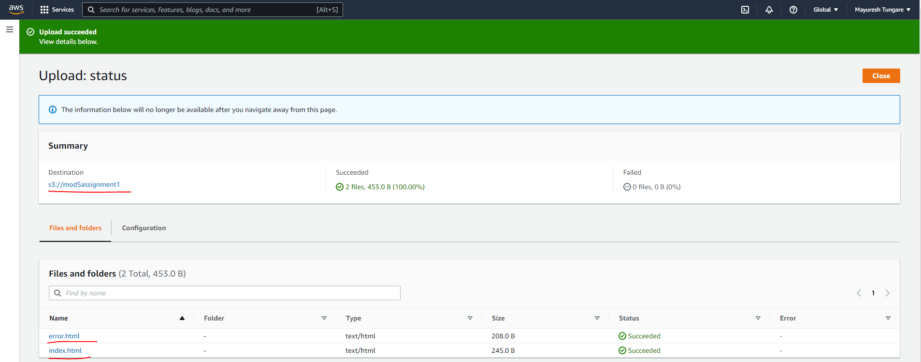

* Created a lifecycle rule (**Transition60**) that moves objects from Standard to Standard-IA in 60 days.

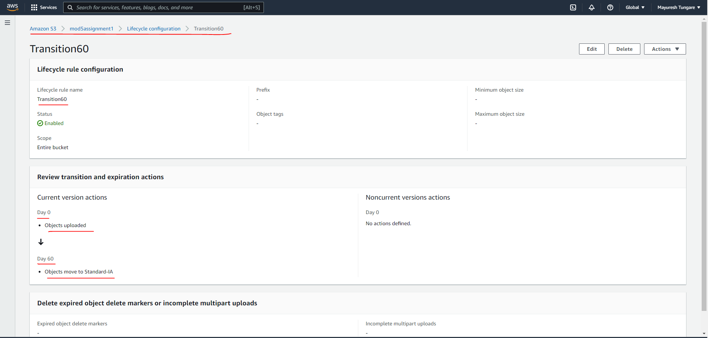

* Created a lifecyle rule (Expiration200) that expires objects after 200 days.

